**MASS WASTING**

Mass wasting refers to the movement of weathered materials downhill or down slope under the influence of gravity. Its therefore the falling, creeping, sliding or falling of rocks and weathered materials downhill under the influence of gravity. The major factor that helps to overcome any resistance is water which water acts as a lubricant for material to move down easily. Water saturated mass moves more easily than a dry one because water both increases the weight of the mass and also decreases the cohesive power of the material.

In other words, mass wasting is a largescale movement of materials downhill in which the stability of the slope has failed. As a result, the materials move downhill under the influence of gravity with water acting as a lubricant. It is alternatively referred to as slope failure or slope collapse.

Mass wasting is a general terminology which includes all forms of movement along a slope ranging from the slowest to the fastest. Therefore, mass wasting refers to the creeping, flowing, sliding or falling of rocks and weathered materials down slope under the influence of gravity using water as a lubricant.

It’s different from erosion in a sense that in erosion, water physically transports away the soil particles but in mass wasting, water doesn’t physically wash away the materials but assists the rock to slide under the influence of gravitational pull.

Mass wasting occurs in highland and mountainous areas of East Africa like along the slopes of mountain Elgon, Rwenzori, Kilimanjaro, Kenya, kigezihighlamds, Kisoro, Rwampara hills, Kipengere ranges of southern Tanzania, Bulecheke areas in Mbale, Sirinko areas among others.

**PROCESSES OF MASS WASTING**

The types of mass wasting include soil creep, talus creep, mud flow, rock slump, rock slide, solifluction, rock falls, avalanches and they can be classified as slow and fast or rapid movements.

**Slow movement processes**. This involves slow movement of loose soil particles down slope. Slow movements processes include the following;

1. **Soil creep:**

This refers to a very slow movement of the soil and fine materials downslope on a very gentle slope. Soil creep can be detected by bending of trees, electric poles, fencing poles etc. in the direction of the slope. It can be witnessed in areas like Nakasongola,Ngeta etc.

**Illustration**

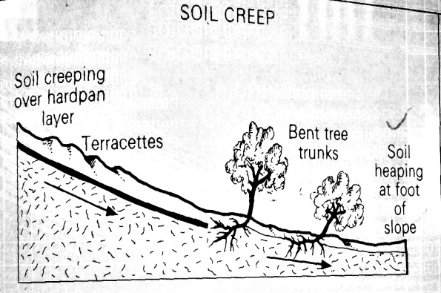

1. **Solifluction:**

This is limited to glaciated regions of cold climatic zones or areas. Solifluction refers to the slow movement of saturated solid gravel materialsover a frozen ground down hill on a moderate slope. It is influenced by conditions of cold climate, hilly or mountainious land scape. In EastAfrica,soluflicationis common in highland areas such as Rwenzori, Kenya and Kilimanjaro where temperatures are very cool.

**Illustration**

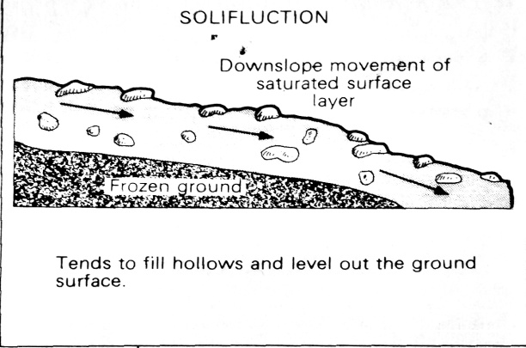

1. **Talus creep:**

This refers to the slow movement of angular wastes or particles of all sizes on a moderate slope. It's common in areas where rock weathering due freeze and thawing which results into angular rock fragments.

It takes place in highland regions on slopes of mountains like Rwenzori, Kenny and Kilimanjaro.

**Illustration.**

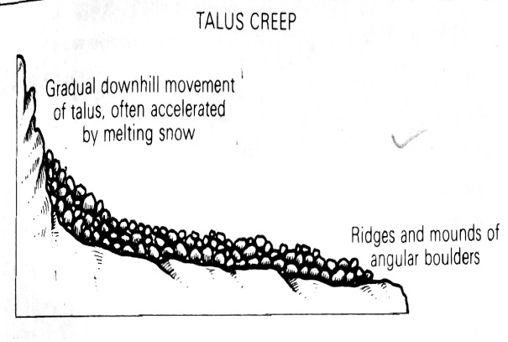

**Fast or rapid movements.**

This refers to fast movement of large masses rock materials on steep slopes down wards under the influence of gravity. Water is a very important factor in land sliding because it reduces cohesion of the surface materials and adds weight to them as well as acting as a lubricant.

**Mud flow:** this refers to the fast downhill movement of semi liquid material (mud mixed with rock boulders) on a moderate or steep slope. Mud flows are common in areas that receive heavy rain fall and large quantities of weathered materials that get soaked up easily and turn into mud which begin to flow down slope under the influence of gravity.

**Illustration**

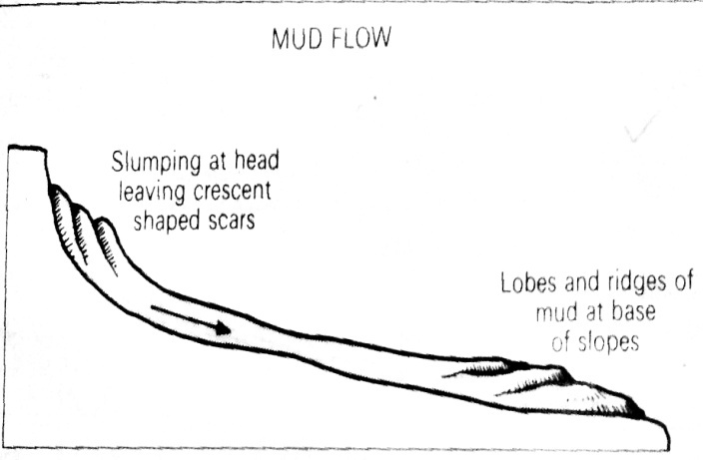

**Rock falls:** this refers to a very fast movement of individual rock masses and boulders falling freely from a very steep slope under the influence of gravity.

**Illustration**

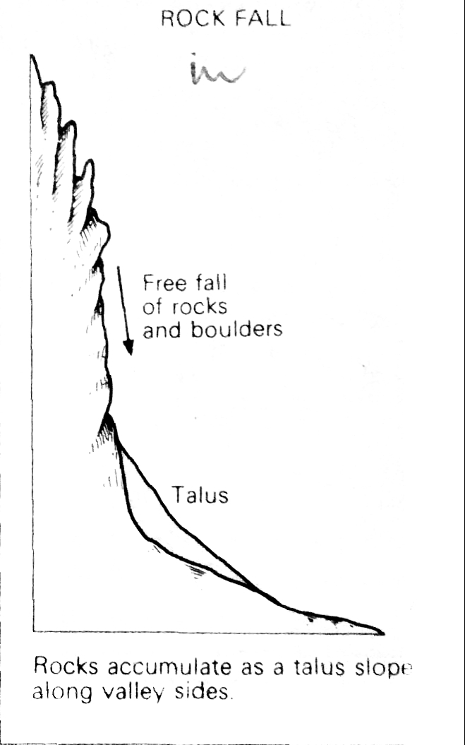

**Rock slump:** this refers to a very fast movement of large rock masses and debris on an over steepened slope like scarps and road cuttings. In slumping, a rock doesn’t break up into different particles in the process of slope failure but the materials just slide as a whole mass. It moves in a back ward rotation such that the slump strata which was originally horizontal is tilted backwards. Slumping is mainly caused by massive rocks overlying weak rocks.

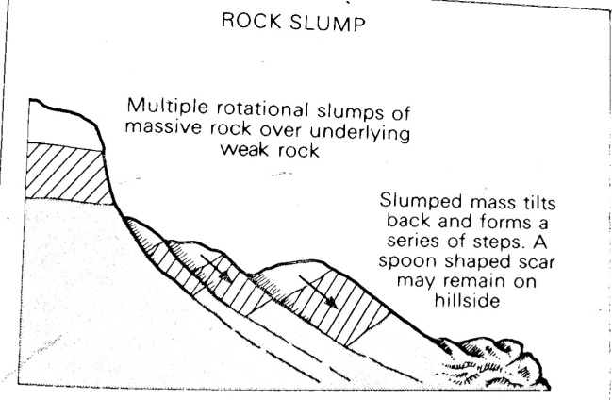

**Rock slide:** this refers to a fast movement of large masses of rocks and debris over a steepened slope and road cutting. Here, the rocks slide from faces of slope or jointed steep slope downward

**Illustration**

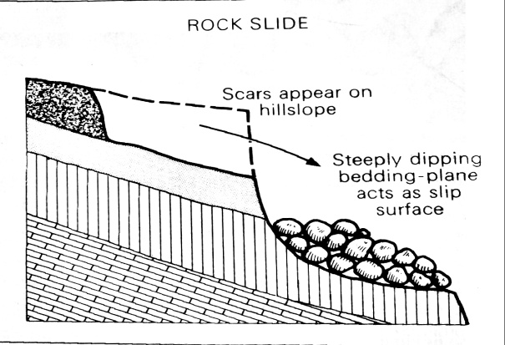

**Avalanches**: this refers to a large scale movement of materials embedded in ice. It’s also the most rapid flowage process since it takes place on very steep slope. This form of masss wasting involves down hill movement of materials emboded in ice and it's occursnce is influenced by the presence of very steep slopes, high level of precipitation and low temperatures which facilities rapid snow formation. It occurrs in highland regions like Rwenzori and Kilimanjaro.

**NOTE:** the rapid movements of materials down the slopes usually involving large boulders and rock particles is sometimes called ***Landslides.***

**CAUSES OR FACTORS THAT INFLUENCE THE RATE AND NATURE OF MASS WASTING**

* **Climate:**
* Some areas in east Africa experience heavy rainfall sometimes exceeding 2000mm per year which leads to the absorption of water by the soils or rocks. This leads to the increase in weight of the soils and rocks and also reduces the cohesion of the material in the mass of the rock as well as acting as a lubricant hence mass wasting in form of rock slide and mud flows.
* -Secondly the pounding effect of direct rainfall destabilizes the rock surfaces resulting into mass wasting.-Drying and wetting conditions in semi arid areas results into loosening of rock materials eventually the un consolidated materials are moved in form of mudflow.
* -Temperature fluctuations results into expansion and contraction of rocks which results into weathering of these rocks and the loosen particles can the easily fall down under the influence of gravity.
* **Relief / nature of the slope,** Steep slopes usually encourage fast or rapid movements of materials downhill e.g. rock slides, rock falls, rock slumps etc. due to the steep gradient.

Gentle slopes on the other hand lead to limited mass wasting and also encourage slow movements e.g. soil creep, solifluction etc.

* **Nature of the rock,** The structure, permeability or porosity of the rock and its jointing determine whether mass wasting will occur or not.
* Highly jointed rocks are prone to rock falls. This is because jointed rocks are easily affected by physical weathering involving block disintegration.
* The loose blocks of rocks produced by frost shuttering can easily slide down wards or downhill in form of talus creep.
* Permeable weathered rocks over lying an impermeable layer are easily lubricated by water hence downhill movement of saturated materials under the influence of gravity eg in form of mud flows.
* **Nature of soils,this** also influences the rate and nature of mass wasting in a way that;
  + fine dry soils in Semi-arid areas encourage soil creeping on gentle slopes
  + Loose sandy soils are affected by increasing temperatures. The temperatures turn the sandy dust which can easily creep downhill.
  + Heavy, wet clay soils that have been saturated and lubricated encourage mudflow and rock slump take place under the influence of gravity.
* Over loading/accumulation of weathered materials in large quantities on the over steepened slopes results into mass wasting processes if rock slide, rock slump and mud flow.
* Earth movements (crustal instability), Areas in east Africa which are affected by landslides are the ones that are prone to the occurrence of the earth’s movement for example earth quakes and earth tremors, volcanicity etc... these destabilize loose particles of rocks and weathered rock materials resulting into mass wasting in form of mud flow and rock slump.
* Human activates make rocks loose and unconsolidated leading to movement of the weathered materials down slope. Such activities include;
* Mining and quarrying at the foot steeps of mountainous areas results into destabilization of loose rocks on steep slope since they are left excavated with tunnels hence landslides which causes cracks eg lime stone mining Tororo, diamond mining in Mwadui in Tanzania etc cause rock fall.
* Road construction works cause rock fall by action of bulldozers as some roads are cut through hilly areas leaving steep slopes on the sides of roads for example along Fort Portal -Bundibugyo road, Mbarara-Kabale road and Kapichorwa road in Uganda.
* Farming practices like ploughing up and down slope, over grazing etc loosen the rock particals hence down hill movement under the influence of gravity eg rock slide and Rick slump.
* Vibrations caused by Heavy moving objects like Lorries, heavy machinery like trains cause vibration of the earth’s surface that trigger off mass movement processes like rock slump..
* Defforestation resulting into rapid loss of vegetation along steep slopes exposses rock materials to mass weathering processes like rock slump.
* Effects of living organisms e.g. barrowing animals like rats which loosen the rocks and the soils resulting into weathering which eventually makes the rocks prone to mass wasting.
* Wild animals grazing in mountainous areas trample on the surface and cause vibrations hence disturbing unconsolidated rock materials and finally results into landslides.

**EFFECTS OF MASS WASTING**

Loss of lives, Severe landslides especially those associated with heavy rains and earth quakes result into rock falls and rock slides that destroy settlements and kill people living in s such settlements like on the lower slopes of mountains like the Bulecheke landslides in 1996 killed about 100 people, in Buhweju many people were killed by the landslide s that occurred in May 2002, 2010 and 2018 on the slopes of mountain Elgon.

Loss of property by the falling and sliding of rocks of various sizes, Many houses and settlements are normally destroyed for example in 1996 in Bundibugyo, a land slide occurred and destroyed several homes and properties for example roads, and electric poles connecting Bundibugyo to Fort Portal were destroyed and that from Kabale to Kisoro. Many crops and the would be agricultural land are often destroyed as they are buried by the debris from the upper slopes.

Destruction of forest resources. When a slope with forests fails, chances are that those forests are rolled down and totally buried and therefore destroyed for example the landslide that occurred in 1985 in Bundibugyo destroyed some good forested area in the Semiliki National Park.

Destruction of agricultural land hencevreducing land use for farming purposes through loss of soil fertility as the top fertile soil is massively carried away in form of soil creep and mud flow.

It results into displacement and resettlement of people to other areas e.g. the recent transfer of people from mountainous areas of Elgon to Bunyoro. This resulted into loss of cultural identity as well as heavy government expenditure to resettle these people.

Mass wasting results into damming of rivers which may result into back ponding to form temporary water reservoirs or permanent lakes eh Lake Bujuku on mountain Rwenzori, Lake Mbaka in southern Tanzaniaresults into exposure of fresh rocks to weathering.

Creation of landforms e.g. terracets, scars, etc. and this has promoted both local and foreign tourists who earn the government income.

Mass wasting results into the provision of fertile soils on lower slopes of hills, mountains by soil creep, exfoliation, etc. which has promoted agriculture in valleys e.g. vegetables growing in the valleys of kigezi.

**MEASURES TO REDUCE LANDSLIDES OCCURRENCE**

Among the measures taken to combat the problems of landslides’ occurrence include the following;

* **Re- afforestation and afforestation.** Planting of tress on the slopes where the trees were cut should be done in order to increase the cohesiveness of rocks. This has been on the slopes of the Kigezi highlands where eucalyptus trees have been planted. The government should establish forest reserves on the slopes and protect them against people’s encroachment. This helps to increase the firmness on the slopes and reduces the chances of landslides to occur.
* **Hill slope drainage.** A lot of water on the slopes increases the lubrication, saturation and weight levels of the rock particles on the slope which accelerates the chances of slope failure and landslides. This therefore means that excess water should be drained away through the drilling of pine lines on the slopes or construction of deep channels or trenches. This has been done on the Kenyan and kigezi highlands. This can also be done through the planting of eucalyptus trees so that they can drain away the excess water on the slopes of highland areas.
* The government should come in to stop people form cultivating on the slopes of mountains and highland areas like on the slopes of mountain Elgon, the kigezi highlands among others whose stability is doubtable. This will help to reduce the chances of landslide occurrence and their associated impacts on the environment and people.
* Agroforestry which involves planting if tree crops like jack fruit,cocoa, mango trees, ovacado trees etc with crops helps to increase tree cover which protects as well as holding the soil particals together againest mass wass wasting.
* Government should also come up with a policy of gazzating specific regions into Forest reserves and national parks so as to avoid excessive deforestation.
* Mass education on environmental protection should be emphasized in areas where Mass wasting is a common phenomenon such that people are tough the likely causes, effects and causes and control measures of Mass wasting.
* In filling of quarry and mining depressions once mining and quarrying has stopped.
* Population control measures should be emphasized since high population densities are the major cause of deforestation in addition resettlement of excess population to reduce population pressure on land to check on the would be chances of the occurance of mass wasting.
* Emphaising better faming methods such as mulching, planting of cover crops, contour ploughing,strip farming etc which help in providing humas, to bind soil particals together, reducing steepness of the slopes and checking surface run off respectivelty hence reducing chances of occurance of land slides.

**Revision questions**

1. **With reference to specific examples from East Africa, examine the causes of mass wasting**

**Approach**

Define mass wasting and site the areas prone to mass wasting in East Africa.

Identify, explain and illustrate the various forms of mass wasting (both the slow and fast movements)

Give and explain the causes of mass wasting linking them to various types of mass wasting

1. **To what extent are the various forms or processes of mass wasting influenced by climate in East Africa?**

**Approach**

Define mass wasting and site areas prone to mass wasting in East Africa.

Identify, explain and illustrate the various forms of mass wasting (both the slow and fast movements)

Thoroughly explain the influence of climate on mass wasting

However, give other factors

Give an evaluation or conclusion